In servlet api programming, we have **two init methods**:

a.



This method is originally declared in **Servlet interface and implemented in GenericServlet(Abstract class).**

This is life cycle method.

This method execution is done only once in Servlet life cycle. So it is **one time execution method**. we generally place initialization logics in the init(-) method like creating jdbc con objection,Initializing the received ServletConfig object to our servlet class obj.

When servlet component class object is created, servlet container invokes the init(-) method. Before invoking the init(-) method, servlet container creates the “servletConfig” object.

The ServletConfig object is 1 per servlet comp class object. Using this object we can pass inputs to servlet component and we can gather more info about servlet component.

EX:- SerletConfig object to ServletComponent class obj is like PA to Minister.

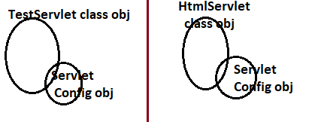

B.



This is not servlet life cycle method.

This is direct concrete method of GenericServlet(Abstract method).This method is given for programmer convience to place the initialization logic like creating jdbc con objection,Initializing the received ServletConfig object to our servlet class obj.

Therefore GenericServlet class have two overloaded init(-) methods.

**Note:-1. Industry recomends writing the initialization logic in 0-param init() method**.

**2. In 1-param init(-) method body, 0-param init() method is invoked.**

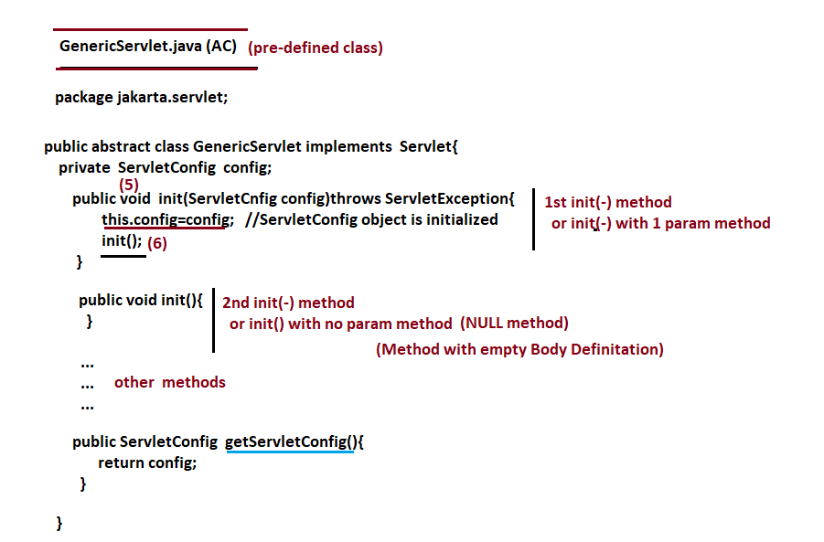

**Execution Flow From request given from Browser(client):**

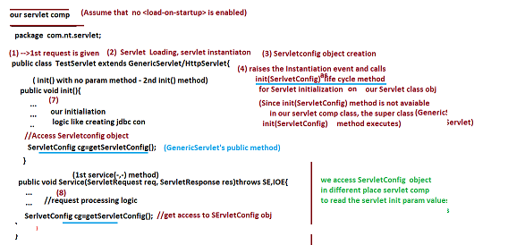

**IMPORTANT POINTS ABOUT INIT() METHODS**

